**Tech Pay Plan Best Practices**

Pay plans should be designed to meet the business goals of your dealership and be competitive with your local employment market. Ford Motor Company doesn’t endorse one particular pay plan, however this document is to assist you in thinking about options so you can design a plan that best meets your needs.

**Business Goals or Objectives** - Step back and make a list of your business goals, examples could include:

* Revenue
* Gross
* Hours sold
* Customer Satisfaction
* Employee Development, Satisfaction, and Retention

**Prioritize** - Next prioritize them from most important to least.

Pay plans should support your list of goals in the priority you selected. They also need to be simple to understand and track. Too many categories that are difficult for your employees to track will lose the desired impact of keeping your team focus on your goals.

Pay plans should also be adjusted to encourage employees to learn, produce, and give back or mentor incoming employees based on the stage of their career. Let’s consider the stages of Technicians and their career.

**Technician Career Stages:**

**Entry Level:**

As students turn to full time Technicians they need to feel they are supported by a network that includes active management, mentors, apprenticeships, and this also extends to how they get paid. Flat rate pay may be good for experienced Technicians that have completed extensive training and honed their job skills allowing them to be efficient. Most Technicians starting in the business don’t have the training and more importantly the experience needed to be efficient. At the same time it’s important that new Technicians learn how to work with a flat rate system if that’s how your journeyman Techs are paid.

**Journeyman:**

Flat rate pay is the most common pay method in US Dealerships as it encourages Technicians to hone their skills to be efficient and by doing so they’re rewarded and can earn a good living. In all other parts of the world Technicians are not paid on a flat rate system. In most markets Techs are considered the most highly trained employees in the dealership and are paid a salary, or hourly rate with a production bonus to encourage efficiency.

**Mentors:**

There comes a time in every successful Technicians career when they have the knowledge and skills but physically can’t keep up the pace and generate the production they once did. It may be time to change their role to give back to new Techs by providing them the opportunity to become a mentor through an apprenticeship.

**Pay Plan Types:**

* Hourly
* Hourly with Sales Incentives
* Hourly with Production Incentives
* Flat Rate
* Flat Rate Tiered with Production Increases
* Flat Rate with Variable Rates
* Flat Rate with Guarantee
* Apprentice Plans
* Team Plans
* Advance Production System Plans with Team Leaders

**Designing Pay Plans:**

Start with the career stage of the Technician(s) to see what type of plan would support your and their goals. Examples of matching the pay plan type to the career stage include:

**Entry Level:**

* Hourly
* Hourly with Sales Incentives
* Hourly with Production Incentives
* Apprentice Plans

**Journeyman:**

* Flat Rate
* Flat Rate Tiered with Production Increases
* Flat Rate with Variable Rates
* Flat Rate with Guarantee
* Team Plans
* Advance Production System Plans with Team Leaders

**Mentors:**

* Apprentice Plans

Now that you picked the type of pay plan, one approach is to start with a budget. What should this person make per pay period, month, and year? Next go back to your business goals and the priority you established.

In this example we’re using an entry level Tech that will work in Express Service:

**Annual Budget:**  $30,000

**Business Goals and Priority:** Employee Development, Product Sales

**Pay Plan Type:**  Hourly with Sales Incentive

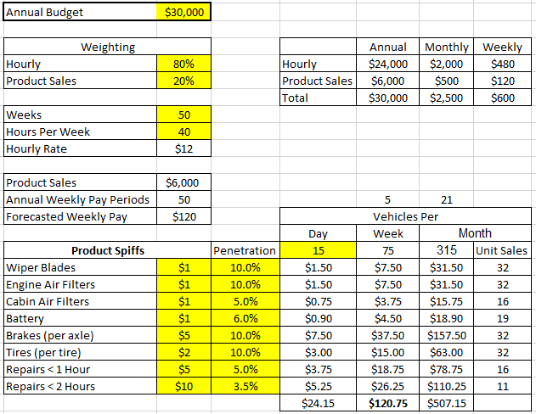

In this example we’re using an entry level Tech that will work in Express Service:

**Annual Budget:**  $25,000

**Business Goals and Priority:** Employee Development

**Pay Plan Type:**  Hourly with Flat Tracking and Growth Option

This allows you to start the entry level Tech with an hourly rate and track their flat rate hours sold with the option to pay the greater of the two pay options. In this example when the Tech produces 30 or more hours per week they earn more than the hourly rate and get an increase of $10,000 per year at 40 hours per week, allowing them to grow into the job.

